***Code Execution and displaying Output***

**Step-1:** Create Console application.

**Step-2:** Copay class file code (image), and paste in Program class file.

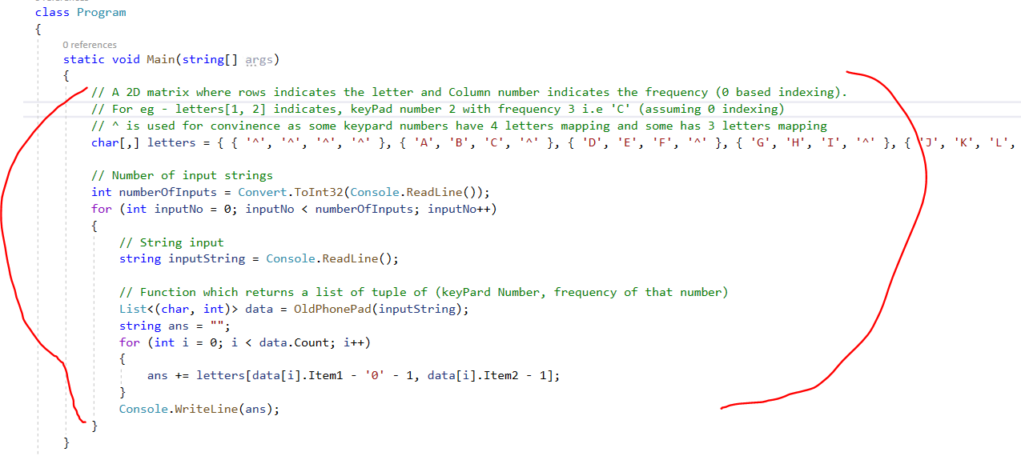

**Step-3:** Copy **OldPhonePad** () method and paste in Program class file.

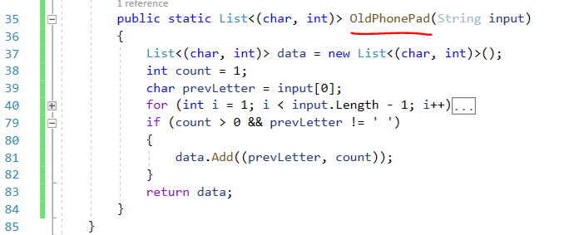

**Step-4:** Run Console application (F5) and key-in number of entry’s (10).

1st entry: Input value: 2

Output: **A**

2nd entry: Input value: 22

Output: **A**

3rd entry: Input value: 222

Output: **C**

4th entry: Input value: 222 2 22

Output: **CAB**

5th entry: Input value: 33#

Output: **E**

6th entry: Input value: 227#

Output: **B**

7th entry: Input value: 4433555 555666#

Output: **HELLO**

8th entry: Input value: 8 88777444666*664#

Output: **TURNING**

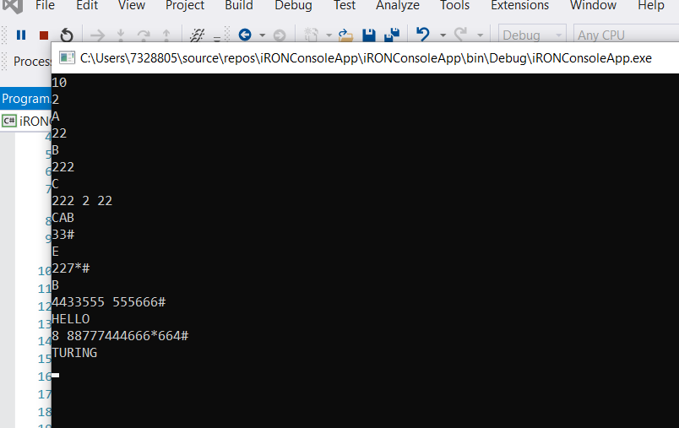

**Git Hub URL:**

https://github.com/gandhigoli/iRONsoft_OldPhonePad.git